# Social Determinants of Heart Diseases in Low Economic Status Population Assessment 1 Answer

|  |  |
| --- | --- |
| ASSESSMENT BRIEF | |
| Subject Code and Title | PUBH6000: Social, Behavioural and Cultural Factors in Public Health |
| Assessment | Assessment 1: Report ‐ Social Determinants of Health |
| Individual/Group | Individual |
| Length | 1,500 words |
| Learning Outcomes | This assessment addresses the following learning outcomes:   1. Analyse the impact of social, environmental and behavioural factors on the health of different populations 2. Analyse population health outcomes and the major social, economic, political and cultural forces that contribute to health inequalities 3. Apply theoretical frameworks to develop effective health promotion interventions. |

Task description:

Background

Tobacco consumption in any form, lack of physical activity, a diet high in fats and sugars, hypertension, obesity and diabetes are well‐known behavioural risk factors for heart disease.

Populations with lower socioeconomic status are more likely to have increased behavioural risk factors for heart disease, including smoking and lack of physical activity (Australian Institute of Health and Welfare, 2010). Although behavioural risk factors might be evident causes of diseases, public health professionals also consider social and environmental factors that contribute to the social gradient of health.

Instructions

Choose a population group in Australia (e.g. men/women, low socioeconomic status, rural/remote, people with disabilities/mental illness). In 1500 words, address the following:

* Describe the burden of heart disease within your chosen population. Please describe burden of disease in terms of any two of following: incidence, prevalence, mortality, morbidity, survival or quality of life.
* Discuss how the social determinants of health can explain the burden of heart disease within your chosen population.
* Propose a public health intervention to prevent heart disease in your chosen population that addresses at least one social determinant of health (e.g. working conditions/ unemployment, social support, transport, housing conditions, education, access to healthcare).
* Explain what other sector/s could be involved aside from the health sector (e.g education, local government, transport, housing) in your public health intervention.

This task can be addressed by including two sections in the body of your assessment. Section 1 focuses on the burden of heart disease for your population and the social determinants relating to this. Section 2 proposes an intervention to address a social determinant and prevent heart disease in your chosen population. Please see the template below for more details about how to address this task.

Introduction

Assessment 1: PUBH 6000 Report: Social Determinants of Health.

Assessment 1 Template.

* Provide a short introduction which gives the reader an overview of the whole assignment. Briefly introduce the public health problem (heart disease) and identify the specific population group that your report will focus on. Explain that your report will propose an intervention to address a social determinant of health for this population group.

Section 1: Social determinants of Heart disease for [Chosen population]

* Burden of heart disease within your chosen population

Provide an overview here of the burden of heart disease in your chosen population: referring to two of the following: incidence, prevalence, mortality, morbidity, survival or quality of life. In this section, you should summarise and appropriately reference information you have found from sources such as the Australian Institute of Health of Welfare (AIHW).

* Discuss how the social determinants of health can explain the burden of heart disease within your chosen population.

Here you should discuss how the burden of heart disease in your chosen population can be explained by social determinants. Consider t health inequities and the social gradient here, and how disadvantaged or advantaged your population is relative to the broader

Australian population. Identify any particular social determinants that are relevant for understanding the burden of heart disease in this population group. Make sure you support all your points with evidence from appropriate sources.

Section 2: An intervention to address social determinants of Heart disease for [Chosen population]

* Propose a public health intervention to prevent heart disease in your chosen population that addresses at least one social determinant of health (e.g. working conditions/ unemployment, social support, transport, housing conditions, education, access to healthcare).

Propose an intervention here to prevent heart disease in your chosen population. This can be a completely new idea or you can draw on ideas from research you have done on existing interventions (for example, physical activity or nutrition interventions). Either way, it must be clearly explained how your intervention could prevent heart disease, and how it addresses one social determinant of health. Clearly identify what this social determinant of health is. In terms of justifying that this intervention can contribute to reducing heart disease, and why taking action on the particular social determinant of

health is important, make sure you support all your points with evidence from appropriate sources.

* Explain what other sectors can be involved aside from the health sector

Identify here what other sectors could be involved in your intervention. Examples of other sectors include (but are not limited to) education, housing, transport, local government. Identifying one sector is fine. Clearly explain how this sector/s would be involved in the intervention and justify why including this sector is important.

Support all your points with evidence from appropriate sources.

Conclusion

* Provide a brief conclusion which does not introduce any new information, but ‘ties the assessment together’. It should provide a recap of the information discussed in regard to the burden of heart disease for your population and social determinants of this. It should also give a short overview of the intervention that was proposed. This provides a useful overall summary for the reader.

General points

* Please use sub headings for sections 1 and 2 as per this assessment brief. Introduction and conclusion do not need subheadings.
* Appropriate scholarly sources include peer review journal articles, subject readings, academic books and book chapters and publications from reputable grey literature sources. Reports from the Australian Institute of Health and Welfare (AIHW) are likely to be particularly useful, as well as other Australian Government sources, and reputable NGOs such as the Heart Foundation. The World Health Organisation (WHO) is also an important source of publications.

Please look for publications from these sources such as reports, rather than relying only upon information available on their webpages.

* Please cite at least 10‐12 scholarly sources for this assessment.
* Ensure your report is written in a clear manner, including spelling, grammar, structure, tone and accurate referencing in accordance with the latest APA guidelines (APA 6th)

Assessment Criteria:

* Displays understanding of the burden of heart disease within a specific population (of student’s choice) (25%)
* Demonstrates analysis of the social determinants of heart disease within chosen Australian population (30%)
* Proposes a suitable and appropriate intervention to address a social determinant of heart disease for chosen population, and identifies appropriate sectors that are involved in the intervention aside from the health sector (35%)
* Assessment Fulfills general academic standards (10%) including: :
* Provide an introduction and conclusion
* Complies with academic standards of writing, including legibility, spelling, presentation and grammar
* Uses appropriate APA 6 style for citing and referencing research

## Answer

****Assessment 1: PUBH 6000****

****Report: Social Determinants of Health****

# ****INTRODUCTION****

According to Sahle et al. (2016), the heart diseases in Australia have been rising and the rate of morbidity due to it can be prevented to some extent at least with interventions. Maiorana & Ntoumanis (2017) also states that the prevalence of heart diseases such as heart failures, CVD, CHD and others can be prevented with proper interventions. There are several factors that are responsible for the issues with heart diseases and the rise in the percentage of the heart problems among the lower-income groups has been predominantly rising as well. Tobacco is regarded as one of the most important contributors to heart-related problems and the impacts of smoking are more pronounced in the low economic status of the society in the country. However, this report would focus on the low-income groups for the examination of the effects of tobacco and smoking among the low economic status population of Australia and present the social determinants of heart diseases as well. The interventions that can be used to mitigate the issues would also be discussed and recommended in detail. The conjunction of other sectors that may contribute to the proper implementation of the interventions would also be explored in it.

# ****SECTION 1: SOCIAL DETERMINANTS OF HEART DISEASE FOR LOW ECONOMIC STATUS****

## ****BURDEN OF HEART DISEASE WITHIN LOW ECONOMIC STATUS GROUPS****

The problem of the heart diseases within the lower economic status of the population can be notably seen with the prevalence as well as a higher rate of hospitalization due to it. According to the Australian Institute of Health and Welfare (2020), the disparity of heart attacks is 1.55 times higher in males of lower economic status than in higher economic status populations. This rate also goes up to 1.76 times in the case of females. The death rate due to Cardiovascular Diseases (CVD) was 1.52 times that of the well to do society for males while it is 1.33 times for the females (Australian Institute of Health and Welfare, 2020). The impact of the socio-economic status of the population can be seen from the fact that if all of the population of Australia had the same rate of morbidity that the total death rate of the country would have reduced by 25 % or there would have been 8600 fewer deaths (Australian Institute of Health and Welfare, 2020).

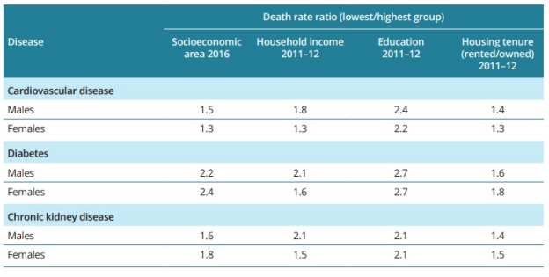

****Figure 1: Death Rate Ratio****

(Source: Aihw, 2020)

Although the CVD death rate has decreased gradually from 2001 and yet the disparity is notable due to a higher reduction of the death rate among the higher economic status population. According to AIHW (2020), there has been an increase in the relative as well as absolute inequality in male CVD deaths that has risen from 62 in 100,000 people in 2001 to 78 in 100,000 people in 2011. The relative index of inequality (RII) has also increased to 0.53 in 2016 from 0.25 in 2001. There is also a correlation between education attainment and the prevalence of heart diseases. According to the AIHW (2020) report, people are 3 times more likely to die who have secondary education than the person with a Bachelor's degree. While the differences in economic status can also be noted in the case of diploma holders who are 1.7 times more likely to die (Aihw, 2020).

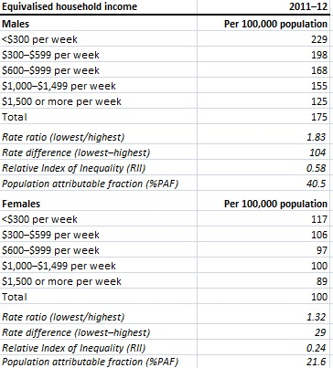

****Figure 2: Inequalities of Income and CVD deaths****

(Source: Australian Institute of Health and Welfare, 2020)

The report from Aihw (2020) also shows that according to the rate of inequality in 2016 there would have been 8600 fewer deaths in Australia due to CVD. It was also reported that the gaps between the male CVD deaths have been widening and there would have been 19700 lesser deaths due to CVD if the lower economic status population had the same rate of deaths as the highest economic groups. According to Aihw (2020), the socioeconomically disadvantaged sections of the society have a higher rate of heart-related diseases.

## ****HOW THE SOCIAL DETERMINANTS OF HEALTH EXPLAIN THE BURDEN OF HEART DISEASE WITHIN THE LOW ECONOMIC STATUS****

There is a myriad of links and associations that can contribute to the higher rates of heart-related diseases in the lower economic sections of the society. The social determinants such as income and education can heavily influence the lifestyle as well as the health interventions that are received by the lower economic groups. According to Aihw (2018a), the contribution of the social and economic factors accounts for 34 % of the gap between the two groups. The impact of smoking, alcohol and high blood pressure accounts for 19 %. The report of Aihw (2018a) has also suggested that 11 % of the heart problems of the population of the country can be attributed to the social and health risk factors.

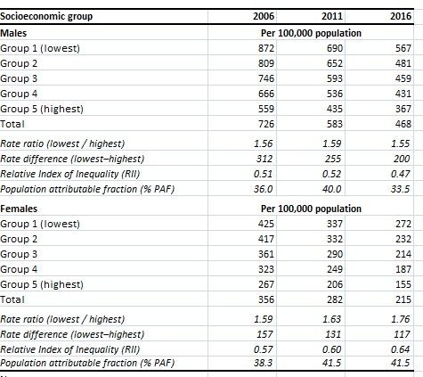

****Figure 3: Deaths due to heart problems in socioeconomic groups****

(Source: Aihw, 2020)

Bull et al. (2018) have also iterated that the low-income groups of the country have an innate connection with the predominance of smoking habits. While Grace et al. (2017) have stated that higher smoking habits among the population are characterized by higher chances of heart problems as well in addition to other health issues. Thus, the conjunction of the arguments helps to deduce that the smoking habits of the population of the country is intricately associated with the heart problems and the increase of the rate of tobacco consumption among the people of the country has also translated itself in the form of rising heart diseases rates as well as mortality due to it. In a nutshell, it can be deduced and provisioned that the lower-income groups of the country are affected due to excessive tobacco consumption, smoking, unhealthy lifestyle that are proponents of the lower-income characteristics of the community.

# ****SECTION 2: AN INTERVENTION TO ADDRESS SOCIAL DETERMINANTS OF HEART DISEASE FOR LOW ECONOMIC STATUS****

## ****PUBLIC HEALTH INTERVENTION TO PREVENT HEART DISEASE IN LOW ECONOMIC STATUS****

The health interventions that can be proposed for the improvement of the heart diseases and mortality or morbidity due to it comes from a range of social factors. The recommendations of the paths that can be followed are as follows:

* The unemployment of the low economic groups should be increased so that the lifestyle choices, as well as the affordability of the people for better health choices, can be made. Shalit et al. (2016) have also proposed that the low income of the population as a factor that impacts bad health choices. Thus improvement of the employment would result in an indirect betterment of the heart diseases as well.
* The education of low-income groups can also be utilized to improve heart conditions. González-Chica et al. (2017) have also pointed out that the education of the low-income groups of the country impacts the perceived knowledge of the risk associated with heart problems. Thus it can become an effective way for the reduction of heart diseases.
* The public health interventions and care should also be extended to low-income groups to engage and educate them about the detrimental effects of heart problems and how it can be avoided. The risk of obesity and no physical activities can also be highlighted through this channel and heart risks can be reduced.
* Tobacco consumption needs to be reduced. The choice needs to change that the need for a better and healthier living among the population can be notably seen to be low due to the economic inability of the people. This explains one of the most important factors that have a part to play for the rising rates of heart diseases among the lower-income groups of Australia.
* Martínez-García et al. (2018) have reiterated that the social determinants such as low income and social status impact the welfare of the population as well as impacts the heart diseases of the people of the country. The economic status is interlinked with the quality of life as well as the lifestyle of the people and the heart diseases are more pronounced if unhealthy lifestyle choices such as smoking, junk food, less physical activities are made. According to Carey et al. (2017), there is a link between the income of the population and the lifestyle that affects the conditions of the heart in the long term as such the income range of the people should be increased.

## ****OTHER SECTORS THAT CAN BE INVOLVED ASIDE FROM THE HEALTH SECTOR****

Aside from the health sector, the education sector can also play a part in the improvement of heart diseases as it can help them to gather important knowledge about the detrimental effects of heart diseases as well as the factors that influence and impact it (Hayward et al. 2017). The education department can actively canvas for educating the masses. Government funding and intervention should also be increased manifolds.

# ****CONCLUSION****

It can be concluded from the above discussion that the heart problems in Australia is rising and the health interventions should be injected with vigour if the population and especially the low economic status population are to be saved from it. The education and the unemployment ratio evident among the low economic groups of the country should be redesigned and funded properly by the Government of the country to raise awareness among the population about the heart diseases. The combined effect of greater awareness and healthier life choices may help the country in reducing the rates of CVD deaths and help to overcome the problems of heart problems.