# Recovery Focused Nursing Care Plan for Postpartum Depression Assignment 1 Answer

Assessment 1: Assignment Recovery Care Plan

Assessment 1: A Recovery Focused Nursing Care Plan.

Learning Objectives Assessed:

This assignment assesses Learning Objectives:

Determine a holistic assessment of consumers and groups with speciﬁc mental health issues, identifying knowledge and skill deﬁcits related to mental illness and treatment, symptom management, available resources, self-management, coping, and rehabilitation

Utilise supportive interventions with consumers and carers including empathic listening, comfort, caring, validation of feelings and practical assistance

Plan, implement and evaluate crisis intervention strategies in the care of MH consumers.

Information and Marking Guide

Please ﬁnd attached the Following material for the Recovery Focused Care Plan:

The written Recovery Focused Nursing Care Plan information package (including the Marking Rubric).

## [NURS2098 2020 RECOVERY FOCUSED NURSING CARE PLAN INFORMATION PACKAGE 01- 01-2020.PDF](https://rmit.instructure.com/courses/62785/files/11318273/download?wrap=1)

The Correct Format Word Template for you to use.

## [NURS2098 RECOVERY FOCUSED NURSING CARE PLAN CORRECT FORMAT WORD DOCUMENT.DOCX](https://rmit.instructure.com/courses/62785/files/9640647/download?wrap=1)

The Two Scenarios: you need to choose 1 and base your RFNCP on this.

## [NURS2098 2020 CMH&R RECOVERY FOCUSED NURSING CARE PLAN SCENARIO 1 RACHELLE.PDF](https://rmit.instructure.com/courses/62785/files/11318325/download?wrap=1)

[NURS2098 2020 CMH&R Recovery Focused Nursing Care Plan Scenario 2 Jack.pdf](https://rmit.instructure.com/courses/62785/files/11318326/download?wrap=1)

An exemplar for you to consider in preparing your assignment.

## [NURS2098 2020 RECOVERY FOCUSED MENTAL HEALTH CARE PLAN EXEMPLAR- LUKE](https://rmit.instructure.com/courses/62785/files/10613349/download?wrap=1)

I will also discuss this assessment in the Week 1 lecture so please have a good listen to that recording in preparing to complete.

## Answer

Title: Recovery Focused Nursing Care Plan for Postpartum Depression

****Case study: Rachelle****

Rachelle is a 31-year-old woman who has delivered a girl named Claire 10 weeks ago. However, she is not able to develop the bond with her daughter and considering herself a bad mother. She is living with her husband who provides the necessary support.

* Rachelle is experiencing peripartum onset and feeling depressed due to not being able to provide necessary care to her daughter.
* She is also finding it difficult to perform her daily activities such as doing household chores and cooking and spending most of the time on the bed.
* She has also so lost 8 kgs of weight in the last two months and sleeps 10 to 15 hours every night.
* She recently lost her brother in car accident, with whom she was not in talking terms and also lost her father 10 years ago who died from myocardial infarction.
* She also has a sister who has had cervical cancer and currently recovering efficiently, but she feels that she will die in the near future.
* Before the delivery, Rachelle has been a dedicated worker who takes pride in her job and her ability to organise complex tasks.
* She has also had suicidal thoughts but has not developed any suicidal intent or plan.
* Being the admitting nurse for Rachelle, I will be responsible for developing the recovery care plan for her to overcome her depression and melancholia feeling.

****HONO score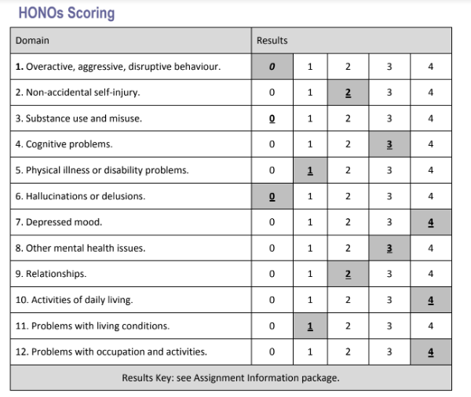

|  |  |  |  |  |  |
| --- | --- | --- | --- | --- | --- |
| ****Consumer priority**** | ****Identified Goals/Issues**** | ****The Consumer’s Strengths to address these issues**** | ****Consumer and Nursing interventions**** | ****Person responsible**** | ****Timeframe**** |
| Rachelle wants to overcome her feeling of worthlessness, guilt and hopelessness so that she can provide the best possible care for her daughter (Shankar et al, 2017). She is not able to concentrate efficiently because she is always occupied of negative thoughts that she is a bad mother, which is affecting her personal life. She wants to reduce her sleeping time and get rid of anxiety so that she can dedicate herself to her daughter. | Issue: The main issue includes feeling depressed and melancholic, due to which she continuous to cry intensely because she is not able to develop a bond with her daughter (Kang et al, 2020). Sleeping for 10-15 hours is causing her negative thinking and affecting her life goals.  Goal: Rachelle wants to feel valued and become a good mother. She also wants to get back her face in God. | Rachel is a goal-oriented and hard-working woman who is highly dedicated to achieve her goal which can be highly effective in making her feel good as a mother and overcome her depression. Apart from that, her good perception will also prove to be beneficial in overcoming have depression and anxiety. | The admitting nurse should assist Rachelle to plan her daily activities which include nutritional intake, sleep, exercise, etc which will help up the patient to overcome her social isolation and improve her mood swings.  As for Rachelle, it is important for her to identify positive strengths and challenge her feeling of hopelessness and guilt. She can do this by expressing her feelings with her husband and the nurse. | Rachelle has agreed to take the responsibility to take care of her daughter by fighting her feeling of worthlessness and hopelessness (Shankar et al, 2017). She is also attempting to avoid crying and try her hardest to develop a bond with her daughter. It is also the responsibility of the admitting nurse to find any difficulty the patient is facing when it comes to taking care of her child and provide solutions. | Risks associated with Rachelle's condition needs to be analysed and reviewed within a week of her admission in inpatient mother and baby unit (Cherry, 2019). To overcome her social isolation and intensive crying, it will at least require two weeks of continuous monitoring and treatment. |
| She wants to become a good mother for Claire and a good wife for my husband (Polmanteer et al, 2019). She wishes to reduce the guilt that she has not been breastfeeding her daughter effectively and not trying harder. She also wants to lead a healthy lifestyle where she can perform her daily household chores and spend quality time with her family. | Issue: Since the birth of her daughter, she is feeling increased dysphoria, feeling of guilt and worthlessness, social isolation and crying intensely. She still goes to weekly attendance at Church (Polmanteer et al, 2019).  Her guilt of not try harder to breastfeed her daughter due to which she believes she is not developing Bond with her daughter. She is also experiencing mood swings, which is making her feel angry. Her guilt of not making things good with her brother before he died.  Goal: To overcome her feeling of guilt and dysphoria so that she can feel connected with her family. | She is highly oriented to the place, time and person and has a very efficient judgement and insights (Ganann et al, 2019). This can be useful for her to reduce her guilt and develop a strong bond with her family. She also has a clear sense of what is good and what is not which can help her make good decisions regarding her condition (O'Hara et al, 2019). | The nurse should also perform an active role in initiating communication which is extremely important to observe the behaviour of the patient and encourage her to talk and write down her feelings. She should also laugh during the conversation and point out the value of humour which will make her feel cheerful. The nurse should also educate the patient on how to relieve from the symptoms of depression by recognising her distorted perception, and monitor her progress after therapeutic and medication treatment. The nurse should also ask the patient about her current condition, and educate her to deal with negative feelings. | Martin is also providing necessary support to Rachelle by continuously engaging in conversations and delivering emotional support (Shankar et al, 2017). The admitted nurse is also educating Rachelle about the feelings of being a mother and how she can provide necessary care to Claire. She is helping her identify her fear and with effective therapeutic care, encouraging her to believe her (Yan et al, 2019). | To help her breastfeed Claire efficiently and develop a bond with her daughter, it may take 3/52 weeks of time, during which the admitting nurse will help her in teaching breastfeeding and taking care of the child (Tong, 2018). |
| Another priority of the consumer is to get rid of the fear of losing her sister just like she lost her father and brother in early stages. She wants to dedicate her life to being a good mother and also get back to her professional life by overcoming her issue of social isolation (Polmanteer et al, 2019). She also wants to regain her professional ability which includes critical thinking, well organised and hardworking. | Issue: The increasing fear that she will kill herself or her sister will die, which is leading her to social isolation (Sun et al, 2019). She is feeling that she has lost all her ability of dedication and commitment and will not be able to be useful for her family.  Goal: To make her understand that everything will be fine to reduce her anxiety and intensive fear through proper support. To increase her confidence level and make her understand that it is only a bad phase. | Even though she is experiencing intense fear and anxiety, she is not experiencing hallucinations and delusions, which is efficient in eliminating her anxiety (Tan et al, 2016). And with her intact memory and her ability to remember past events is also useful to address the issue. | She should also advise Rachelle of regular baby care which will allow her to breastfeed Claire and develop a strong bond. Rachelle should also communicate with her husband and fight the low self-esteem to overcome insecurities and dysphoria feelings. It is also necessary for the nurse to provide with physical requirements of the patient include healthy diet, self-care and personal hygiene along with good massage to improve sleep. | Rachelle is also self-exploring to understand her weaknesses and why she is feeling guilt and anxiety (Sun et al, 2019). This is helping her understand her current condition and eliminate the feeling of self-harm. She also needs to communicate more openly with her husband and the nurse which will enable her to recover from depression. | In order to overcome the guilt and fear of losing her sister, it can take 2 weeks of proper treatment and education along with family support. Continuous medication for the next 3 months is required to overcome anxiety condition and Improve self-esteem. |

****Recovery Focused Mental Health Care Plan for Rachelle****