# HI5017 Relevancy and Challenges of the Standard and Target Costing Assignment Answer

|  |  |
| --- | --- |
| Assessment Details and Submission Guidelines | |
| Trimester | T3 2019 |
| Unit Code | HI5017 |
| Unit Title | Managerial Accounting |
| Assessment Type | Assignment |
| Assessment Title | Individual Assignment |
| Purpose of the assessment (with ULO Mapping) | Students are required to develop their understanding of the purpose and use of management accounting systems, and its usefulness in aiding managers make informed decisions. You are to critically evaluate the literature (using journal articles) to analyse the practical use of management accounting systems by contemporary companies, in terms of their relevance to the real-life companies’ decision-making by  managers and achievement of business goals (ULO 1, 5, 6, 7 & 8) |
| Weight | 30% of the total assessments |
| Total Marks | 30 |
| Word limit | Not more than 3,000 words. Please use “word count” and include in assignment. |

Purpose:

Individual Assignment Specifications

This assignment aims at developing your understanding of the purpose and use of management accounting systems, and its usefulness in aiding managers make informed decisions. You are to critically evaluate the literature (using journal articles) to analyse the practical use of management accounting systems by contemporary companies, in terms of their relevance to the real-life companies’ decision-making by managers and achievement of business goals.

Assignment Task:

Journal Article Critique (30 Marks)

You are required to conduct a literature search and discussion in this assignment.

You are to choose a peer reviewed journal article (from any country) on the:

* Use of Standard Costing in a real-life company; and
* Use of Target Costing in a real-life company.

Register the two article names and details with your Lecturer in class. The articles should be published between 2010 – 2019. Choose your articles only after you have accessed several relevant articles, and then choose the best articles that will answer the assignment question below.

Required: Critically evaluate the relevance and challenges of both costing systems by answering the 5 questions below:

Questions:

1. Briefly discuss the features of standard costing as a planning and control system. (5 marks)
2. Based on your standard costing article, discuss the relevance of standard costing as a planning and control system in your real-life case company. Did it satisfy the features discussed in (i)? Why or why not? Include examples in your answer from your standard costing article. (5 marks)
3. Discuss what target costing is and compare and contrast it from standard costing. (5 marks)
4. Is target costing relevant in today’s competitive and (in most cases), uncertain business environment? Explain with examples from your target costing article. (5 marks)
5. Based on your literature findings (above), which of the two systems would you recommend for contemporary organisations to use for planning purpose and which system you would recommend for control purpose? Explain (5 marks)

Additional Information:

1. You are encouraged to choose the journal article from the following Accounting and Management Accounting Journals:

[Accounting, Auditing and Accountability Journal](https://search.proquest.com/business/publication/publications_31671?accountid=30552); [Journal of Management Accounting  Research](https://search.proquest.com/business/publication/31820/citation/6A92B992C7C74BC4PQ/3?accountid=30552)[Journal of Applied Management Accounting Research](https://search.proquest.com/business/publication/publications_40108?accountid=30552)

1. You can access these journals in ProQuest Database by clicking on the above links. Log in details for ProQuest are - Username: Holmes2004; Password: Holmes. These journals can also be accessed via the ProQuest Database link available via the Student Login page in the Holmes website. You can also use Google Scholar. Don’t use Google.
2. No student can choose the same article as another student from the same class, else both students may receive a zero mark, at the Lecturer’s discretion.
3. The two journal articles must be uploaded (as a separate PDF file) together with your assignment (as a MS WORD file format) in Blackboard under the folder <Assignment>. 5 marks will be deducted if you do not submit the articles with your assignment.
4. Assignment Structure:

The report should include the following components:

1. Assignment cover page clearly stating your name and student number
2. Abstract (one paragraph)
3. Table of contents
4. A brief introduction or overview of what the report is about.
5. Body of the assignment with appropriate section headings
6. Conclusion
7. List of References.

## Answer

Target and standard costing

****Introduction****

With the ramified changes, organization needs to strengthen the[business](https://www.abcassignmenthelp.com/business-development-assignment-help) process system by implementing the particular costing method to bifurcate the costing in the different process. This report reveals the relevancy and challenges of the standard and target costing. In the starting of this report, features of the standard costing as planning and control system has been taken. After that, relevance of standard costing as a planning and control system and trading costing method have been taken into consideration. Therefore, this report, reveals the implication of the both costing methods and the choice of selection of the particular costing method in the business process. However, it has been evaluated that the selection of the particular costing method is dependent upon the industry type, customer base, and company status, and purpose of such system. This report reveals the proper implication of the target and standard costing. In addition to this, difference between the given both costing method have been used to assess the proper costing method.

# ****RELEVANCE AND CHALLENGES OF STANDARD AND TARGET COSTING****

## 1. ****FEATURES OF STANDARD COSTING AS A PLANNING AND CONTROL SYSTEM****

****Standard costing**** is an alternative cost accounting method for the historical costs based traditional cost accounting method. Standard costing is cost accounting method in which expected costs of the goods or services are pre-determined and estimated for each of the expense under normal conditions, even before the starting of the production or rendering of such goods or service starts; and subsequently records the variances from the actual costs (Clifton, Townsend, Bird, & Albano, 2019).

****Features of the standard costing**** as a planning and control system:

Assigning cost and profit responsibilities to each practical level of supervision – Standard costing segregates the costs for lowest practical level of the supervision and identify and assign the profit responsibilities to such every supervision level. This segregation and profit responsibilities helps the organization to plan and control the cost and profit from the particular supervision level and further improves the control system of in the production line.

Comparing and measuring the actual results and engineered standards – Standard costing assigns the responsibilities among the departments and cost centers, after the commencement of the production, the cost accounting method monitors and records the actual data and calculates the variances by comparing the engineered standard and the actual costing; which provides the organization a complete details of scope of cost centers and departments or supervision levels where the deviation is concerning (Clifton, Townsend, Bird, & Albano, 2019).

Providing up to the per minute contribution data for decision making – The cost accounting method provides the data of contribution up to the level of per minute to the management which takes the form of tool for analysis and planning for improving the cost structure while monitoring the results and effects of the decisions taken during the period.

Providing the realistic planning and vigorous control for each level of the management – As the standard costing provides the pre-determined cost data as per engineered standards as well the actual costs and profits of the products and services, further analyses the variances for each of the supervision level like material, labor, and overheads and segregates the variances on the basis of efficiency, idle time, purchase prices, labor rate, and usage of the material; it provides the realistic planning and vigorous control structure for all level of the management. This helps in the finding the reason for the variances and provides the control over each of the expense exceeding from the pre-determined costing for normal conditions (Clifton, Townsend, Bird, & Albano, 2019).  -

Enabling the management for taking the remedial steps for unfavorable variances – standard costing, by analysis and reporting the variances for the each element of the operation - material, labor, and overhead and further identifying the cause for each of the unfavorable variance like price variance or efficiency variance, it helps the management to take the remedial steps for such unfavorable variances. Form this, the organization producing the similar output on the repetitive basis, benefits by taking such remedial steps and by communicating such steps to the employees.

Features and process of standard costing can be understood with the help of below inserted graph –

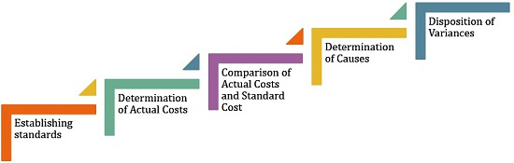

Source: (Standard costing, 2019)

Relevance of standard costing as a planning and control system in X Wire and Cable Company

The standard costing can prove to be most relevant and efficient cost accounting method for organization providing similar output. Standard costing is relevant for the organizations due to the importance of the method in following areas –

Increase in the efficiency – the organization involved in the manufacturing activities having the various elements of cost of the final output and involving a complex production process, can improve the efficiency by adopting the standard costing which would provide a engineered standards for such cost elements and proper communication in the employee hierarchy would increase the efficiency of the cost accounting, labor, and monitoring of the production process. X Wire and Cable Company is manufacturing company, so the standard costing would help the company with an increased efficiency.

Budgeting and decision making – standard costing is important while the budgeting as the standard costing uses the engineered standards for each cost element which later supports in making an appropriate budget. As the standard costing provides the comprehensive data about the whole production system and cost elements, it helps management in decision making and taking the decision by analyzing the whole details summarized in the most efficient manner.

Cutting the clerical costs – Standard costs communicates the standard cost and standard production for the normal conditions to the employees and labors which reduces the clerical costs of managing the whole cost elements separately in a manufacturing company like X Wire and Cable Company. This reduction in clerical costs helps the organization to come out form the profit squeeze (Laviana, et al. 2016).

Identifying the price-cost relationship – Standard costing helps the organization in decision making as this method of costing accounting helps the organization to understand the price cost relationship by segregating the cost elements with the most practical supervision level. X Wire and Cable Company benefited by the standard costing as the company was earlier struggling in understanding the actual profitability with respect to the sales as said by the sales manager of the company (Du,  Ge, Zhang, & Chen, 2017).

Integration of planning and control element – standard costing is relevant for the X Wire and Cable Company and the relevant for the likewise company as this helps the company in making profit plans and monitoring the same by integrating the same. The X Company was unable to accurately assess the profitability of the investment of the $40,000 in Teflon tape line due to inefficient cost accounting method, standard costing can handle these situations in an efficient manner and help in making profit plans.

As reported in the article and discussed above, it can be concluded that the standard costing had satisfied the features for X wire and cable company by satisfying the management in various areas like, pricing decision, better cost control, and profit planning. It can be said after observing the inefficiency of earlier cost accounting system as the sales and production managers were unable to assess the profitability of the Teflon tape line, understand the product costs, and find the relationship between the sales and the profitability as reported in the article. After implementing the direct standard costing, the management was able to make pricing decision after taking the helps of some aids which were based on the direct standard costing only; further management found that they need to double the utilization of the Teflon tape line to generate a fair rate of return on investment (Akhavan, Ward, & Bozic, 2016). Furthermore standard costing helped the management in taking the profit decisions by defining sales responsibilities and providing a better forecasts and budget which also changed the defensive attitude of the management taken toward the usual budget.

## 2. ****TARGET COSTING AND STANDARD COSTING****

****Meaning of target costing –**** Target costing is method of costing under which the company determines the life-cycle cost of the product after considering the desired level of profit margin, sales prices in the competitive market, and the specified features and quality of the product. It can be defined as a management technique also in which company plans for product life cycle in planning and designing level of new product after considering the several factors like market price forced by competitiveness, features and qualities required for product, margins and return on sales (French, et al. 2016). After considering these factors, company gets the target cost by subtracting the target cost form the expected market price, the cost which company can afford to achieve the targeted profit. Target costing involves market research, designing and product level costing, and component level costing.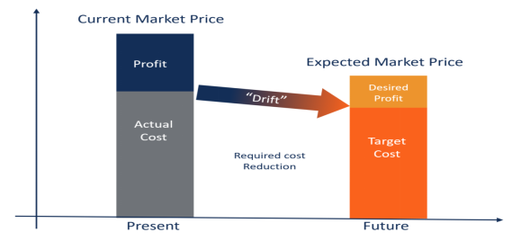

****Key features of target costing –****

In target costing, selling price of the product is taken after taking into account the market conditions; the company accepts and plan as per this price rather than quoting its own price.

Desired return on sale is taken in account at the time of planning, and then the required reduction in the cost is calculated without compromising with the features and functionaries of the product.

Cost reduction target is being formed after considering all the product specifications, customer expectations, and design at the time of planning only (Vetchagool, Augustyn, & Tayles, 2018).

To integrate all the production cycle activities like designing, manufacturing, and marketing; a team is formed.

****Advantages of target costing –****

Company gains competitive advantage due to the management’s commitment and involvement in the product innovation and improvisation.

With the market driven approach of designing and manufacturing, company manufactures market driven products and helps the company to seize the market opportunities, and benefit by economies of scale (Hoozée, & Hansen, 2018).

Customer feels more valued it considers the customer expectations; and it successfully motivates the employees and enforces the cost management plans.

****Process of target costing –****

Target costing process can be divided in three major sections – market driven costing, product level target costing, and component level target costing. Market driven target costing consist of establishing company’s long term profit and sales goals, deciding the appropriate product mix, identifying the selling price after market research of the product, identifying the return on sale of each product, and calculate the maximum allowable cost (Darzi Ramandi, Kalhor, Emami, & Kiaei, 2018).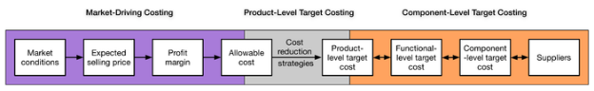

Source: (Process target costing, 2019)

Product level target costing focuses on the product design after considering the results of the first step. Product level target costing considers the company’s in house designing capabilities and decides the cost reduction target. The product target costing can be summarized in chart as in the one inserted below (Clifton, Townsend, Bird, & Albano, 2019).  -

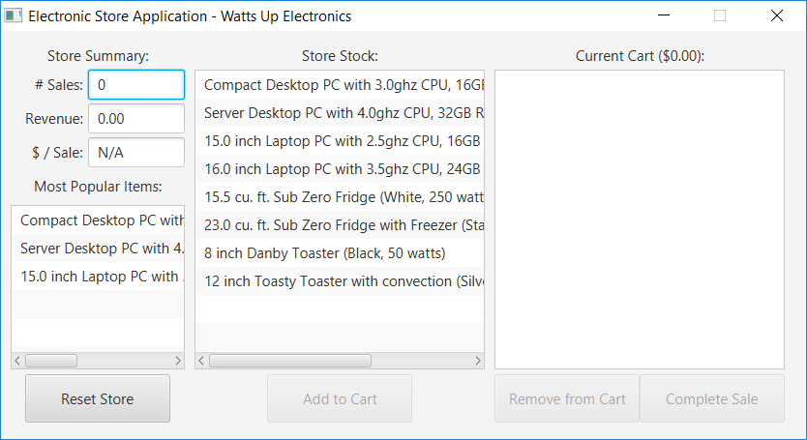

Source: (Product target costing, 2019)

Component level target costing decomposes the production cost to each of the component and function level. After identifying the cost reduction targets, this process finds way to achieve them with engineering methods like value engineering (VE) (Defourny, et al. 2019).

****Target costing and standard costing –****

|  |  |
| --- | --- |
| ****Standard costing**** | ****Target costing**** |
| Standard cost is unit cost under normal condition predetermined with the engineered standard, applies to existing production and working conditions. | Target costing provides target for cost reduction after considering the desired profit, which may require changes in the existing working conditions. |
| Standard costing involves the forward calculation and usage the enterprise data for calculations (Lu, He, & Luo, 2018). | In target costing, calculations are based on external and market data and backward calculation is done to set the cost reduction targets and achieve the desired profit. |
| Standard costing is useful for existing and similar products and usually computed for existing products and services. | Target costing is used at the planning and designing phase of the product. |

## 3. ****RELEVANCE OF TARGET COSTING****

Target costing is completely useful and relevant in today’s competitive and uncertain business environment, as the target costing is based on the market data and external data for calculate a practical and actual reduction targets. Conventional methods of costing are not sufficient to meet the requirement of the enterprises in fast-changing business environment and shorter product cycle, and competitiveness in market and fats improvisation in products. As target costing is applied at the planning and designing stage of the product, it considers the need of innovation and competitiveness in the market and sets the reduction target for the company accordingly.

Target costing is relevant in today’s competitive and uncertain business environment; this can be understood from the CPA journal which relates the target costing and bottom-line of the company. Target costing is relevant in today’s business environment due to the following reasons (Vetchagool, Augustyn, & Tayles, 2018).

Ever changing product life and requirements – the product life cycle is getting shorter due to the product innovation, automation and use of robots in the tech and other industries. Due to this the conventional production lines are not relevant and the costing systems based on that are not sufficient to meet the requirement due to such change.

Control at early stage – target costing controls the cost at the planning and designing phase which meet the need of today’s competitive market as the cost control at the manufacturing stage may not meet the profit desires of the company (Visscher, et al. 2017).

Sets the target costs and connects with the profit planning – target costing takes the profit margins in center and then decides the target reduction in cost, which fulfills the company’s need of profit in competitive market which is tough to achieve from conventional costing which starts in manufacturing phase and adds the profit margin to the company’s product cost. Competitiveness in the market does not allows the companies to be the price maker and the target costing fulfills the requirements arose due to this shift in company status.

Compatibility with emerging costing systems – as companies may requires different costing systems at the same time, the compatibility of target costing with emerging systems like ABC costing and activity costing makes it more relevant in today’s changing business world.

4. ****Recommended costing system for planning purpose and for control purpose****

Costing system of the company helps the company in decision making and deciding the budgets and many other different ways. The right and appropriate selection of costing system is important for the company given the role of these systems, and current business world, many companies follow different costing systems for different purposes (Defourny, et al. 2019).

 The selection of the costing system depends of the industry type, customer base, and company status, and purpose of such system. Standard costing system which was introduced in 1920s is followed widely for determining the costs and calculating variances and improving the production cycle whereas the target costing was recognized by the industries in 1990s after observing the successful implementation by the Japanese car makers and benefits of the system. Target costing focuses on market competitiveness and provides targeted cost reduction to achieve the desired profit. So, after considering the objective and use of the systems, it can be recommended that for planning purpose, company should use the target costing given the innovation and the competition level in the market; and for control purposes and monitoring purposes, selection of costing system depends on the level of required cost reduction and actions taken for the same (El Alaoui, & Lindefors, 2016).For motivating and enforcing the reduction targets, target costing is efficient and for monitoring the similar output only, standard costing can be used also. Given the planning and control efficiencies in present competitive and uncertain market, aside from the manufacturing companies, about 15% construction projects in Japan have adopted the target costing, and this system is being used in energy and healthcare sectors as well. So, as the standard costing is traditional method and can be used for similar output and service sectors, target costing can be used for better planning and control purposes in the industries and companies where it can be followed (Aleks, Litovskaya, & Ponomareva, 2018).

****Conclusion****

After assessing all the details given in the both articles, it could be inferred that the target costing and standard costing both are valuable costing method which could be used by companies to bifurcate the costing in the different prices system. In addition to this, the adoption of the particular costing method in the process system is based on the variable factors which may impact the business process costing in the organization. However, after analyzing both the articles in this report, it has been found that the target costing is better and cost effective. The implication the target costing method in the process lower down the costing value and also helps in strengthen the process costing bifurcation in the various process.