# Career Episode on Electrical Design of 400 KV Transmission Line

University: University Of Nairobi

Task:

Write the topic on "Career Episode on Electrical Design of 400 KV Transmission Line".

## Answer

****a) Introduction****

****Location:**** Belgium

****Name of the organization****: National Grid, GRT in Belgium

****Project Title****: Electrical Design of 400KV Transmission Line

****Position Title:**** Electrical Engineer

****b)  Background-****

****Nature of the overall engineering project****: The main objective of the project is to adopt an electrical design framework for the erection of 400 KV Transmission Line. The project starts with the basic introduction of transmission lines and its basic laying principles with a brief survey on the type of lines to be laid in the destined location. The basic reason behind conducting this project is to meet the rising power demands of Belgium. A transmission line is a cumulative design for the transfer of electrical energy from one place to another. The higher voltage transmission lines are laid as a part of insulation clearances in different areas of the country. The project encapsulates different insulators design for aiding the geometrical configuration of the transmission lines in order to cope up with the adverse climate conditions. The Earth wire, which is called the ground wire need to be, connected with the transmission lines directly to implement disaster resistance in case of lightning or any unusual natural activity.

****Objective of the project****: The brief objective of the project is to increase the power generation in Belgium for meeting the increasing power needs of the nation. The aims revolve around grounding tough electrical lines for transmission purposes with a variety of insulation techniques to prevent corrosion and rusting of cables. This cost efficient module represents the basic design of transmission lines along with lying of high voltage lines integrating with the national grid of Belgium for indicative clearance of the basic design. The fundamental aims of this project are grouped below:

* To set up step up and step down transformer at destined location in  order to change the voltage as per requirements
* To optimize the changing optimal load and cost of setups
* To successfully install ground wires for earthing purpose
* The mechanical strength of the conductors should be very high

****Organizational Structure:****

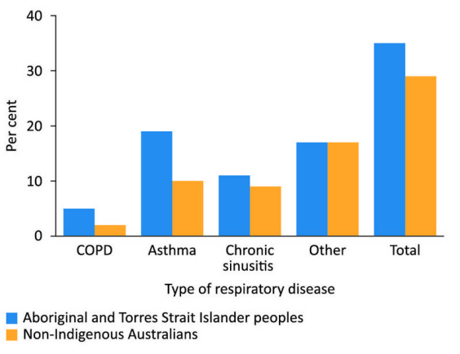

This represents a typical organizational structure in which the supreme authority is overtaken by the founding chairperson and the reliable operation of activities depends on two sectors that comprises of the Financial Aspect and the Engineering aspects of the organization. In the Engineering aspect, the whole work can be divided into two departments- one is planning and the second is execution.

****Statements of Duties****: There is a wide statement of duties to be looked upon while planning the transmission system, which are given as follows:

* Planning and designing the transmission framework before execution
* Ensuring double- circuited transmission means with the aid of at least three conductors
* To ensure commercial entity of the cost transmission line
* To prevent sagging of the conductor due to overloading of the line

****c) Personal Workplace Activity****

Career Episode on Electrical Design of 400 KV Transmission Line,Organizational Structure, Statements of Duties, Technicalities of the Work****:****

Several aspects need to be highlighted in this given scenario for giving a technical sound to the project. Some of them are:

****Transmission Line:**** It mainly indicates a device for transferring electrical energy from one point to another. The transmission lines consist of high voltage wires ranging from 70 KV to nearly 400 KV as a part of relative ground works in design requirements of voltage lines.

****Components of Transmission Lines:**** The main components of a transmission line are conductor, insulators, earth wire, pylon and foundation. The conductor allows the flow of charged particles throughout the line that gives a reinforced condition for current carriers.

****Corrosion Prevention****: The rust is mainly formed due to the ambient collection of metallic inclusions from the surrounding environment, which acts as a barrier in the flow of electricity.

****Earthing:**** It is done by connecting a wire to the transmission line through ground to prevent any casualty to the transmission system due to lightning.

****Application of Engineering Knowledge and skills:****

The main Engineering Knowledge’s and Skills used in this context includes:

* The concept of power loss where P, voltage by V, represents power and current by I is represented by:
* The Economic voltage of transmission power is used to calculate the length of the wire carrying current. It is represented by  E=5.5
* The terrain is categorized in three types that mainly include coastal areas, cross country lines and urban built areas.
* It also inculcates knowledge about dead centre and load cell that needs to be aligned with the construction of transmission lines.

****Important task delegated:****

The important tasks delegated in this project include the execution of electrical transmission lines along with reliable requirements for the construction and procurement activities. It also includes survey of electrical lines for engineering installation works, which is segmented into three survey types. These types include preliminary survey, reconnaissance survey and fabrication survey. The erection of towers also engaged a large number of manpower’s including uplifting and overturning activities. Earthing activities is als0o executed along with grounding activities for prevention of electrical casualties.

****Technical problems faced during the execution of work:****

The estimated transmission system should be of 400 KV lines. However, at the operational end, it is evident that the optimal power transmission is not done correctly due a set of operational gaps:

* The average amount of power that needs to be transmitted through the line is often limited due to the variation of the length of the line. The thermal losses due to overall heating of the line depend on the length only.
* The sagging problem of the conductors may be profound if there is a huge amount of current drawn through the conductors as it may cause overheating of the wire. A voltage drop is inculcated in lines of long distance to ensure that there is no overheating in the line.
* The power of an AC line is directly proportional to the sine of the phase angle between the receiving and the transmitting end. This angle largely depends on the loading of the system and its generation and thus the interdependency is affected largely.
* The estimated product of the line and load is proportional to the square of the system voltage. Therefore, the strong current lines are limited because of thermal and voltage dropout levels.
* The electrical resistance of the line depends upon its thickness largely and thus thickness of the line has to be increased for smooth transmission. It also adds to the cost of transmission.
* The earthing wires are generally indulged in the bottom of the tower for the installation of Earthing pipes which also affects the size of the pipe largely and thus the towers on both sides of the rail crossing needs at least 2 pipes to be connected. This also increases the cost of transmission.
* Sometimes, heavy fault current is flown through the outskirts of the conductor, which interrupts the railway signals and telecommunication adding to discrepancy on the transmission part.
* The erection of towers needs to be done on the right foundation and thus a load cell is needed to be integrated in the structure, which involves straining of cables away from the tower for specifying the load.

****Design work:****

The design work mainly delegates to the sagging aspect of the transmission line, which indicates the curvature of the line during loading of the conductor. Therefore, the design of the line must be as such that in cases of overloading the line can resist as much loading as it can take under normal conditions. The normal sag length along with a pictorial presentation of sagging is depicted below:



Here, the maximum span length gradually decreases as the loading increases and therefore, it can be inferred that the optimum span length is indirectly proportional to the loading encountered. The catenary aspect correlates length, sag and tension of the conductor and the Catenary formula is reoriented by   L= 2H/q Sinh Sq/2H, where

D depicts sag of the conductor

L depicts length of the conductor

T depicts tension at either point of support

H depicts horizontal tension at the lowest point

It also includes the load requirements for transmission lines that comprises of reliability requirements and safety requirements in a schematic way.

****d) Summary****

The transmission mechanism is a largely growing industry in the modern world as it is the necessary module to meet the rising need of power in the world. It not only transfers power from one point to another but also responsible in generating employment for a large variety of skilled and unskilled workers in various parts of globe. It also increases the share of several other industries by generating huge demands in their perspective scenarios. These industries are Agriculture, Power, Manufacturing, Trade and Commerce. The basic designing aspect of the transmission line emphasizes on the basic capability of the transmission mechanism to meet the future needs of the world by reducing power losses and strengthening energy transfer largely. The power transmission can be optimized by improving the voltage profiles, expanding, and relying on different power systems.