# ACCT6001 Database on MS Access Platform for Butler Financial Companys Mortgage Assessment 4 Answer

|  |  |
| --- | --- |
| ****ASSESSMENT BRIEF**** | |
| ****Subject Code and Name**** | ACCT6001 Accounting Information Systems |
| ****Assessment**** | Assessment 4: Database Application – Case Study |
| ****Individual/Group**** | Individual |
| ****Length**** | 1500 words +/-10% |
| ****Learning Outcomes**** | *.* This assessment addresses the following subject learning outcomes:   1. Explain the characteristics of relational databases and their role in creation and communication of business intelligence 2. Apply technical knowledge and skills in creating information for the workplace using spreadsheets and relational databases. 3. Communicate with IT professionals, stakeholders and user   groups of information systems. |
| ****Weighting**** | 30% |
| ****Total Marks**** | 100 marks |

# ****CONTEXT:****

The aim of this assessment is to assess the student’s ability to solve business problems using database design tool and software. It also aims to enable students to think about the impacts of using IT in Businesses and communicate key issues through a written report.

Many companies depend on the accurate recording, updating and tracking of their data on a minute-to-minute basis. Employees access this data using databases. An understanding of this technology allows business professionals to be able to perform their work effectively

****Instructions:****

Create a database from Butler’s spreadsheet that does not have any data anomalies. Use appropriate E-R diagrams to explain the relationships. To test the database, you can create a query to show which borrowers ( both borrower number and name took out loans from Excel Mortgage and who the Appraiser was for each loan

You are able to use MS Access to complete this assessment.

****Submission Instructions:****

A word document containing:

1. Introduction - a summary of the case study
2. Justification of the use of database
3. Database Design: E-R Diagram
4. Microsoft Access files used in creating the tables, forms, queries and reports

****Criteria:****

* Need for the implementation of the database
* E-R Diagram
* Normalised Database Tables
* Queries
* Forms and Reports

****Case Study:****

The Butler Financing com[any runs a mortgage brokerage business that matches lenders and borrowers. The table below lists some of the data that Butler maintains on its borrowers and lenders. The data are stored in a spreadsheet that must be manually updated for each new borrower, lender or mortgage. This updating is error-prone, which has harmed the business. In addition, the spreadsheet has to be sorted in many different ways to retrieve the necessary data.

****Answer****

****Introduction****

The aim of the report is to provide information about the database built on MS Access platform for the Butler [Financial](https://www.abcassignmenthelp.com/financial-services-assignment-help) Company’s Mortgage business. As data is an important asset for any business, so they need to ensure proper processes to capture, store, and process data. Traditional file based systems are no longer efficient enough to store and process data as a business grows. Hence, they need suitable [database](https://www.abcassignmenthelp.com/database-assignment-help) applications to store and process data.

In the following sections of the report, Butler Financial Company has been used as a case study. The report contains information about transforming their spreadsheet based system into a suitable relational database developed on the MS Access platform.

# ****JUSTIFICATION OF THE USE OF THE DATABASE****

Butler Financial Company runs a mortgage brokerage business. They keeps details of borrowers, lenders and property appraisers in order to match borrowers against lenders to make a deal successful. Once they are also to match and close a deal successful then they earn commission as brokerage service charge. Currently they are storing all data in a spreadsheet based application that require manual updates to be done for each new borrower, lender or mortgage. The update process is highly prone to errors and it needs to sort the spreadsheet in different ways to ensure that data is retrieved based on different conditions.

The justifications of using database for the Butler Financial Company are listed below.

* A database management system helps to store data based on inherent logics and relationships of data.
* A DBMS helps to deal with data redundancy issue. For example, if the same data is used across multiple files, then it needs to keep all those files updates when the data is updated. If one file is missed then that will contain an obsolete version of data. Now, if any application tries to take data from that particular file, then it will process the obsolete version of data and that will product wrong or obsolete results. This is not desirable in any business. Hence, it needs a database system where enforcing referential integrity helps to keep track of the updates through all relations or tables in a database. So, at any point of time, all relations or tables in a database will contain updated data only ([Abraham Silberschatz, Korth & Sudarshan 2015](https://www.abcassignmenthelp.com/acct6001-database-on-ms-access-platform-for-butler-financial-companys-mortgage-assessment-4-answer" \l "_ENREF_1" \o "Abraham Silberschatz, 2015 #16)).
* It helps to automate data input process. Hence, it does not need to make manual data entry for all tables. So, there are lesser chances of errors and the consistency of data in a data base is more than a file based system.
* Users are allowed to retrieve data from a database easily using various forms of queries, reports etc.
* The cost associated to data storage, retrieval and processing is optimized.
* Normalized databases are used to improve performance and consumption of computing resources in terms of storage and processing power. All these not only helps to reduce cost, but also improves the overall performance related to data management for a business ([Abraham Silberschatz, Korth & Sudarshan 2015](https://www.abcassignmenthelp.com/acct6001-database-on-ms-access-platform-for-butler-financial-companys-mortgage-assessment-4-answer" \l "_ENREF_1" \o "Abraham Silberschatz, 2015 #16)).
* It makes reporting easy and automated.
* It helps to run different queries on data sets to sort and process results in different ways.
* It also helps to improve security and privacy of data by implementing different security mechanisms on the datasets of a database. Each field of a database can be locked from unauthorized access and alteration. Different views of same dataset can be created to ensure access of different stakeholders to a database for different purposes ([Abraham Silberschatz, Korth & Sudarshan 2015](https://www.abcassignmenthelp.com/acct6001-database-on-ms-access-platform-for-butler-financial-companys-mortgage-assessment-4-answer" \l "_ENREF_1" \o "Abraham Silberschatz, 2015 #16)).
* User access controls can be implemented on a database. For example, a database can be password protected to allow only a set of authorized users to make changes in the database or to view content of the database.
* It helps to increase integrity of data and to reduce anomalies like insertion anomalies, deletion anomalies, and update anomalies from a database.

# ****DATABASE DESIGN: ER DIAGRAM****

The given spreadsheet of Butler Financial Company is presented below. It is assumed that the name of the un-normalized version of the table is Mortgage.

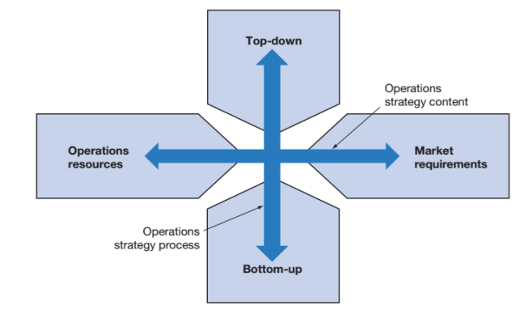

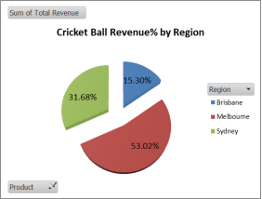

A close inspection on the data presented in the spreadsheet table above shows that there are following functional dependencies in the Mortgage table.

Borrower No à Last Name, First Name, Current Address

Lender No à Lender Name, Lender Office Address

Property Appraiser No à Property Appraiser Name

Borrower No, Lender No, Property Appraiser No à Requested Mortgage Amount

So, a candidate key (or primary key) for the Mortgage table can be {Borrower No, Lender No, Property No}. It is a composite key. And all other attributes are dependent on the primary key. There is no multivalued attribute. Hence, the Mortgage table is in 1NF.

But there are partial dependencies as some of the attributes are partially dependent on the selected primary key. The decomposed relations based on partial dependencies are,

* Borrower (****Borrower No****, Last Name, First Name, Current Address)
* Lender (****Lender No****, Lender Name, Lender Office Address)
* Property Appraiser (****Property Appraiser No****, Property Appraiser Name)
* Mortgage (***Borrower No***, ***Lender No***, ***Property Appraiser No***, Requested Mortgage Amount)

All these relations along with the updated Mortgage relation are in 2NF. Again there is no transitive dependency on any of the relations. Hence, all these are also in 3NF.

The normalized set of relations are,

* Borrower (****Borrower No****, Last Name, First Name, Current Address)
* Lender (****Lender No****, Lender Name, Lender Office Address)
* Property Appraiser (****Property Appraiser No****, Property Appraiser Name)
* Mortgage (***Borrower No***, ***Lender No***, ***Property Appraiser No***, Requested Mortgage Amount)

The ER diagram is,

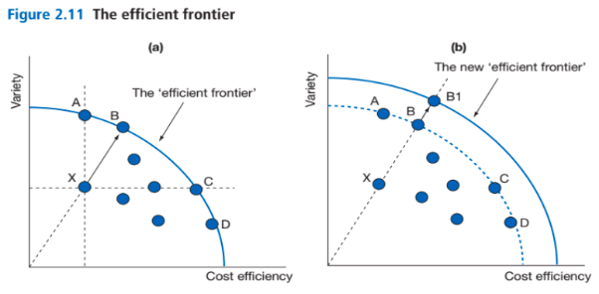

The business rules are,

* A lender lends to multiple borrower.
* A property appraiser appraises multiple mortgage properties.

The assumptions are,

* A borrower can have multiple mortgage on different properties

****Database Implementation: MS Access Database****

The database contains the following normalized tables, queries, forms and reports.

## ****NORMALIZED DATABASE TABLES****

|  |  |  |  |
| --- | --- | --- | --- |
| ****Borrower**** | | | |
| ****BorrowerNo**** | ****LastName**** | ****FirstName**** | ****CurrentAddress**** |
| 450 | Adams | Jennifer | 4 Do Rd |
| 451 | Adamson | David | 5 So St |
| 452 | Bronson | Paul | 3 To Dr |
| 453 | Brown | Marietta | 3 Go St |
| 454 | Charles | Kenneth | 7 Do Rd |
| 455 | Coulter | Tracey | 13 So St |
| 456 | Foster | Harold | 8 To Dr |
| 457 | Frank | Vernon | 14 Go St |
| 458 | Holmes | Heather | 9 Do Rd |
| 459 | Johanson | Sandy | 11 So St |
| 460 | Johnson | James | 12 To Dr |
| 461 | Jones | Holly | 5 Go St |

|  |  |  |
| --- | --- | --- |
| ****Lender**** | | |
| ****LenderNo**** | ****LenderName**** | ****LenderOfficeAddress**** |
| 12 | National Mortgage | 7 Ten St |
| 13 | Excel Mortgage | 6 Shore Dr |
| 14 | CCY | 2 Buck Rd |
| 15 | Advantage Lenders | 3 Lake Dr |
| 16 | Capital Savings | 8 Coral Rd |

|  |  |
| --- | --- |
| ****Property Appraiser**** | |
| ****PropertyAppraiserNo**** | ****PropertyAppraiserName**** |
| 8 | Ad Appraisers |
| 9 | So Appraisers |
| 10 | Jay Appraisers |

|  |  |  |  |
| --- | --- | --- | --- |
| ****Mortgage**** | | | |
| ****BorrowerNo**** | ****LenderNo**** | ****PropertyAppraiserNo**** | ****RequestedMortgageAmount**** | |
| 450 | 13 | 8 | $245,000.00 | |
| 451 | 13 | 9 | $124,000.00 | |
| 452 | 14 | 10 | $345,000.00 | |
| 453 | 15 | 10 | $55,000.00 | |
| 454 | 16 | 8 | $25,000.00 | |
| 455 | 13 | 8 | $216,350.00 | |
| 456 | 12 | 9 | $115,000.00 | |
| 457 | 12 | 10 | $90,000.00 | |
| 458 | 16 | 10 | $450,000.00 | |
| 459 | 15 | 9 | $70,000.00 | |
| 460 | 12 | 10 | $15,000.00 | |
| 461 | 15 | 9 | $65,000.00 | |

## ****QUERIES****

1. Query 1 shows the borrowers with borrower number and name, who took out loans from the lender named, Excel Mortgage and details of the appraisers of the properties.

The SQL code is,

|  |
| --- |
| SELECT Borrower.BorrowerNo, Borrower.LastName, Borrower.FirstName, Lender.LenderName, [Property Appraiser].PropertyAppraiserName  FROM [Property Appraiser] INNER JOIN (Lender INNER JOIN (Borrower INNER JOIN Mortgage ON Borrower.BorrowerNo = Mortgage.BorrowerNo) ON Lender.LenderNo = Mortgage.LenderNo) ON [Property Appraiser].PropertyAppraiserNo = Mortgage.PropertyAppraiserNo  WHERE Lender.LenderName="Excel Mortgage"; |

The output of the query is,

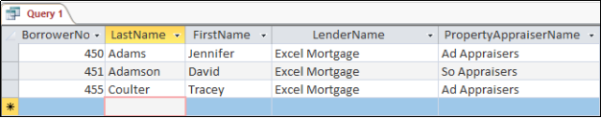The other query lists the names of all borrowers, lenders, and property appraisers of Butler Financial Company. This has been used in the report in the database.

## ****FORMS AND REPORTS****

* The Borrower form is there to enter details of a new borrower.

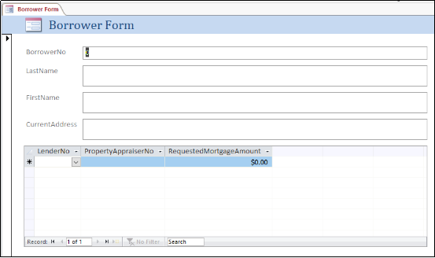

* The Lender form is there to enter details of a new lender.

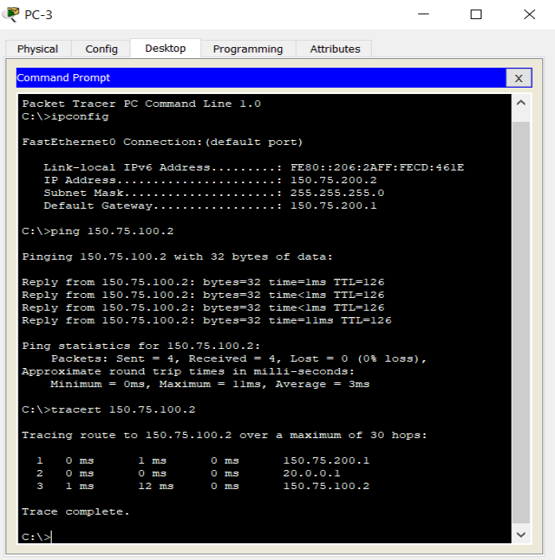

* The Property Appraiser Form is there to enter details of a new property appraiser.

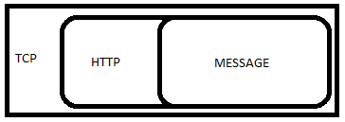

* The mortgage form is there to enter the requested quote of a new mortgage deal.

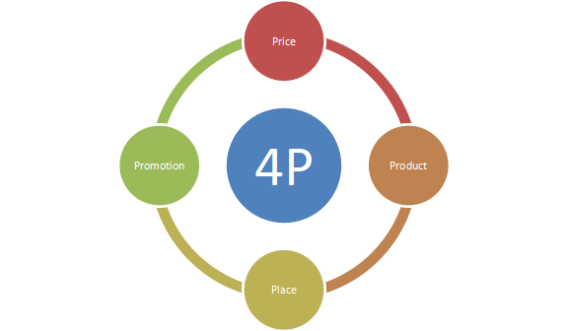

* The report shows the names of all borrowers, lenders, and property appraisers of Butler Financial Company

****IT Security and Privacy****

Security and privacy of data is very important. It can be ensured by protecting a database with suitable security solutions like user access control, encryption and by implementing suitable policies for enforcing security standards and rules ([Abraham Silberschatz, Korth & Sudarshan 2015](https://www.abcassignmenthelp.com/acct6001-database-on-ms-access-platform-for-butler-financial-companys-mortgage-assessment-4-answer" \l "_ENREF_1" \o "Abraham Silberschatz, 2015 #16)). For example, the database can have restricted access to some employees only. Some employees may be allowed to only view data based on searches. Another group of employees may be given the right to change and add data in the tables. It needs to protect the data tables in a database first as those contains raw data. Use of forms and reports helps to reduce direct access to the tables containing data in a database.

# ****CONCLUSION****

The report contains the details of transforming the spreadsheet base file of Butler Financial Company into an MS Access database. The report contains justifications of the use of database and how it has been normalized and implemented in the relational database. It also contains information about the conceptual ER design and privacy and security aspects of using a database in a business.