# COAC216 Business Plan for Work Fit Life Assessment 3 Answer

|  |  |
| --- | --- |
| COURSE:Bachelor of Business / Bachelor of Accounting | |
| Unit Code: | COAC216 |
| Unit Title: | Cost Accounting |
| Type of Assessment: | Assessment 3 – Group Report (5 students in a group) |
| Length/Duration: | 2,000 words (excluding executive summary, tableofcontent, heading & sub- heading, references, appendix & tables) |
| Unit Learning Outcomes addressed: | 1. Discussvariousapproachestoperformanceevaluationandcontrol in various types of organisations 2. Discuss thechangingroleofmanagement accounting. 3. Devise and evaluate simple indicatorsofperformance. |
| Assessment Task: | Group Presentation and Written Report |

ASSESSMENT BRIEF

ASSESSMENT DESCRIPTION:

Students are required to work in a group of 5 students for a presentation and a written report. Students must registerfortheirgroupwiththelecturerin week 4 and 5 and are not allowed to change groupmembers without the lecturer’s permission.

|  |  |
| --- | --- |
| Part | Task |
| 1 | 1. Think about a feasible start-up business model and choose one. 2. Develop a one-page business plan using the Business Model Canvas. (A detailed procedure will be given in Part 1 online training course) |
| 2 | 1. Develop a vision and a mission statement for the business model. 2. Develop a Balanced Scorecard for the proposed start-up business model.   (A detailed procedure will be given in Part 2 online training course) |
| 3 | Perform a break-even analysis for the proposed start-up business model. (A detailed procedure will be given in Part 3 online training course) |

Each group is required to present their work through a presentation and a written report. The details are as follow:

|  |  |
| --- | --- |
| Task | Description |
| Presentation (Presenting to investors) | Goal: Convince your potential investors so that they invest on your business model.  Requirements for presenting groups:   * Photocopy your BMC in A4 (with your group number clearly written) enough to give at least one copy to each group (e.g. if there are 10 groups, your group need to print 10 copies of your BMC) and give to your lecturer on the presentation day; * Duration: 10 minutes * No of presenters: 5 people * PPT Slide: Business Model Canvas (minimum), and Balanced scorecard & BE analysis (optional)   Requirements for participating groups:   * Actively listen to other groups’ presentation and give   $500 stickers (total 20 stickers available per group) to the business models that your group want to invest.  The business model that gets the most of stickers will be awarded as the Best Business Model. |
| Written Report | Each group is to write a business plan report including:   * A brief description of your business idea; * Vision and Mission statement * Business Model Canvas for your business idea (put BMC in your report) * Balance Scorecard (BSC) (what is BSC?, BSC for your idea, translation of strategy of your business model), make sure to put your BSC in your report. * Break-even analysis (BE) (what is BE analysis?, estimated operation costs (not setup cost) and revenue, categorisation of fixed and variable cost, calculation of contribution margin, calculation of BE in unit/service and BE in dollar, overall comment on BE of your business model) * Comment on overall feasibility. |

## Answer

Business plan

Introduction

This report reveals the key implication of the business undertaken and other key issues which business would face in tis business. The business canvas model and balance score card have been assessed to evaluate whether the business incorporating would be viable decision or not. In the starting of this project, business canvas model and mission, vision of the company has been evaluated. After that, the implication of the business balance score card have been taken. The Break-even analysis has also been taken to assess the total costing and profit earning capacity of the organization. This shows the point at which the new startup will have no profit and no loss in its business.

Business description of the business idea

The Work Fit co-working Café is a new startup business which is started with the idea of providing a place to the business person, freelancer, scholars and event programmer. This startup also includes health services such as during the work hygienic and healthy food and in the morning and evening gym and yoga facility by the trainer. This will be the first start-up business that is providing all these services altogether. The company is planning to start a business in all metro cities with a view to provide the places accompanied with the gym and healthy café where people could find the right place to work and stay together in the solitude.

|  |  |  |  |  |
| --- | --- | --- | --- | --- |
| Key Partners   * Raising fund through private funding * Alliance with the company providing work from home services and other IT and restaurants.      * Marketing through online and other means of advertisement * Logistic and supply chain through the alliance with the suppliers. * Retailers | Key Activities   * Direct purchasing organic vegetables and other materials from farmers. * Purchase the best internet services with the firewall service and security. * Integrating the program to facilitate the member to understand and work efficiently * Manage all the service efficiently and effectively | Value Proposition   * Offering to the member the best quality service in all the key areas. * Providing them customization services in their membership plan to avail the best services * Offering various discounts and price offers from time to time. * Following the approach of cost leadership style | Customer Relationships   * Introducing the services according to the member like an employee, students, freelancers * Bring the new experience in this area of working and fitness * Motivational speeches, yoga and gym competition, and meditation program * Developing the healthy, workable and friendly atmosphere | Customer Segments   * Freelancers * Scholars or university students doing the research * Health sensitive users * Users willing the Gym and yoga facility after or before working hours * Member likes to work with a healthy diet in breakfast, lunch, and dinner |
| Key Resources   * Marketing team * Primary and supporting activities * Human resources management and team * Initial investment and operating capital * Different management and transaction processing software such as Enterprise resource planning and management information systems | Channels   * Organic food * Internet services * Gym and yoga trainers * Cooking staff and dietician * Advertisement team * Social media * Official website |  |  |  |
| Cost Structure   * Leasing expenses * Marketing expenses * Installing the Gym machinery and internal control system in the company * Employees salary * Fixed cost such as rent, bill, utility * The infrastructure development cost for business. * Salary to the trainers and visitors | | Revenue Streams   * Offering working places * Event management programming space * Gym and yoga facilities * A healthy diet and food services * Fitness club * Library space for students and scholars * Generating income from the various activities from schools and other programs | | |

Business canvas model

The element in this start-up business has been discussed and pointed out with the business canvas model where the plan of start-up business has covered the key area that plays a significant role in business planning. The objective behind this business plan is to achieve the target of providing all these services and attracting the people to join it as the member.

# MISSION AND VISION OF THE BUSINESS

Work Fit Café is starting its business from a city with the best services and looking forward to setting up the business units in every metro city. The business plan developed to provide the best services to the member of the Café who joins the café as a member by subscribing to the membership plan (basics, silver and golden) and avail the services according to their requirements. The company has to set its mission and to achieve it within the times.

The mission of the company can be as follows:

* Heavy subscription of membership plans –

The Company can operate in the market when it is generating income or achieving its sales target. The heavy subscription will generate heavy revenue for the company so that it becomes easy for the company to offer the best services (Kangari, Farid, & Elgharib,2012).

* Promote healthy culture among the members

If the company is getting the title of a healthy working culture then it makes easy for the company to advertise its service and fulfilling the small targets.

* Providing the best services to the member

Total quality management is the approach which refers to the best services and product. This approach is followed from the lower level to the strategic level. Total refers to every stage of the management and quality refers to the best services and management refers to the planning. This is the continuous approach and to be achieved accordingly (Horrigan, 2015).

* Follow cost leadership approach

The company should set its price after determining the target cost because it is the first requirement of the company to achieve its break-even sales.

* Attract the user of the service from different sector

The user from the different sectors refers that the services are not product specific and user-specific. This is also the feedback on the services that they like the service provided by the company (Edmister, 2012).

The vision of the company can be as follows:

* To establish a business unit in every city

Every business goes through various life cycles but its ultimate objective is to achieve growth with upward direction and stability. The company has come with a new idea to settle its business in every different sector and provide them the unique facilities. After getting settled in one city, looking forward to promoting and expand the business to every state and city and also overseas by developing the franchise business (Zietsman, 2019).

* Promote the business and services

As and when the business achieves its target then it is important to motivate its employees and other members by organizing the reward program and honouring them and offering the parties and celebration program every year-end and achieving the targets so that the member happily connected with the companies (Durante, & Turvani, 2018).

* Achieve the targets

Missions and the targets are the subsets of the vision. The company when achieving all its targets and goals timely will facilitate it to achieve its vision objectives (Waters-Lynch, & Potts, 2017).

Balance Score Card 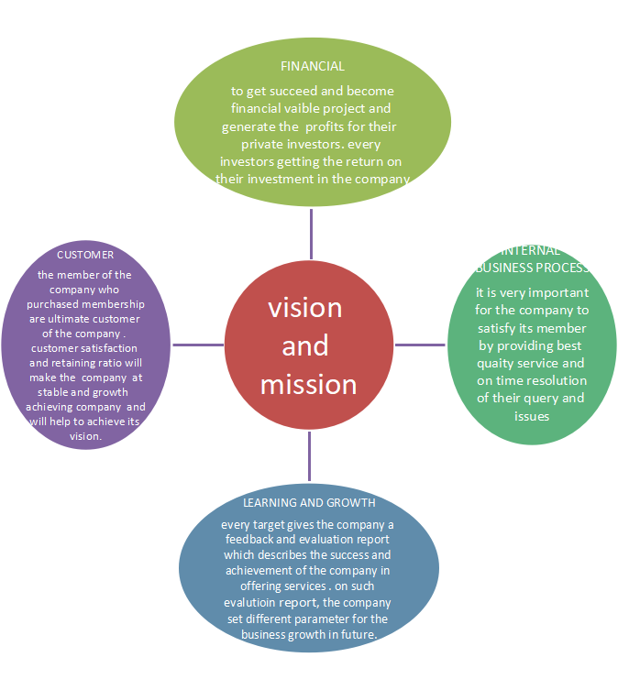

* FINANCIAL -   To get succeed and become a financially viable project and generate the profits for their private investors. Without profit, it becomes difficult for the company to survive and achieve its objectives. Every investor getting the return on their investment in the company
* INTERNAL BUSINESS PROCESS – if all operations of the company are performed effectively then it becomes easier to provide the best product in the environment as it becomes the strength of the company. The company needs to satisfy its member by providing the best quality service and on-time resolution of their query and issues (Merkel, 2017).).
* LEARNING AND GROWTH – planning and estimation is an important task to perform and operate according to and the result is not as per planning then identifies the factor affecting the company adversely. Every target gives the company a feedback and evaluation report which describes the success and achievement of the company are offering services. On such evolution report, the company set the different parameter for the business growth in the future.
* CUSTOMER - The member of the company who purchased membership is the ultimate customer of the company. Customer satisfaction and retaining ratio will make the company stable and growth achieving company and will help to achieve its vision.

Break-Even Analysis

The Work Fit Café is a start-up business which is providing the working place, restaurants and fitness services to the different users. The company generating income is required to meet the cost which is of a fixed nature.  The fixed expenditure is such as leasing, electricity, utility, permanent labor, rent and other overhead. If the company can generate such income or revenue that is enough to pay off the fixed expenditure, it indicates that the company is running on break even.  The break-even point is calculated by dividing the fixed cost by contribution. Every company must reach its break-even point so that it can work accordingly and plan for a margin of safety. The margin of safety is the point where the company generates profit after paying off the fixed cost (Bouncken, Clauss, & Reuschl, 2016).

To analyze the break-even point, the company need to determine the following steps:-

Determination of contribution: - Contribution depicts the amount of revenue that is to be used to pay off the fixed cost and resulting in the profit or loss for the company. The calculated contribution will be used to calculate the break-even point for the company. As the break-even point is the situation where the company is not generating any income or loss, simply means no profit and loss point (Burns, & Dewhurst, 2016).

Computation of fixed cost: - fixed cost is the cost that does not change according to the change in the level of activity and which will occur whether the company is operating or not. To calculate the fixed cost, add up all the running costs of any business. This cost would include rent, salaries of non-production employees, insurance and mortgage (Waxman, 2017).

|  |  |  |  |  |
| --- | --- | --- | --- | --- |
| Table to make chart | | | | |
| Unit | Fixed cost | variable cost | total cost | Sales | |
| 200 | $        80,000.00 | $              50,000.00 | $            130,000.00 | $      116,006.67 | |
| 250 | $        80,000.00 | $              30,000.00 | $            125,000.00 | $      135,000.00 | |
| 300 | $        80,000.00 | $              35,000.00 | $            150,000.00 | $      132,000.00 | |
| 350 | $        80,000.00 | $              40,000.00 | $            175,000.00 | $      135,000.00 | |
| 400 | $        80,000.00 | $              45,000.00 | $            200,000.00 | $      145,000.00 | |
| 450 | $        80,000.00 | $              50,000.00 | $            225,000.00 | $      180,000.00 | |
| 500 | $        80,000.00 | $              55,000.00 | $            200,000.00 | $      185,000.00 | |
| 550 | $        80,000.00 | $              60,000.00 | $            180,000.00 | $      250,000.00 | |
| 600 | $        80,000.00 | $              65,000.00 | $            196,363.64 | $      300,000.00 | |
| 650 | $        80,000.00 | $              70,000.00 | $            212,727.27 | $      325,000.00 | |
| 700 | $        80,000.00 | $              75,000.00 | $            229,090.91 | $      350,000.00 | |

Break-even point – The break-even point is determined by using the total cost and total sales of the company (Chegut, & Langen, 2019).This point shows the point at which company would be having no profit and loss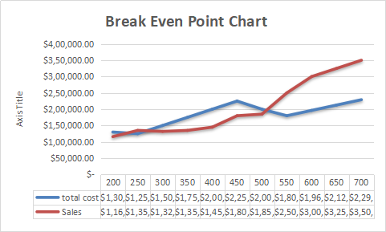

This break-even point reveals that at 250 units company would be having no profit and no loss in its business process (Kangari, Farid, & Elgharib, 2012). Therefore, it could be inferred that if company wants to survive in this business industry, then it will first have to reach to the point at which it could sale its products and services at 550 points.

Conclusion

After assessing all the requirement and details of the newly business case, it could be inferred that newly set up business of Work Fit Life would be more beneficial for the business. However, the business activities and business canvas model undertaken for this work reveals that company needs to set up automation in its business process to lower down the business costing and strengthen the business outcomes. Now in the end, it could be inferred that proper business management financial management activities helps in operating the proper business plan. The financial plans attached helps in evaluating the financial outcomes and estimated financial data for the business.