**CHOSEN ORGANIZATION: *“FIVE POINT FOUR”***

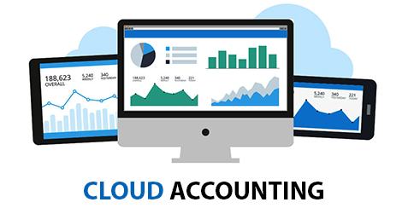

**Executive Summary**

The aim of this report is to recommend and automated accounting software for an Australian SME, namely *“Five Point Four”.* Nowadays, two types of automated tools are used- one I cloud-based and other one are desktop based. In this report, the advantages and disadvantages of both of these are identified. As shown on the report discussion, that cloud-based SaaS provides numerous opportunities over desktop-based software. The security of the cloud-based software is identified as one of the major issue in adopting cloud-based systems. In addition to that, cost and troubles related to hardware implementation is discussed. Price, hurdles, during implementation of this software is discussed in the report. In the comparison section, four types of software have been discussed. Among those, two can be used in both cloud and desktop version and other two can be used in only cloud version. Based on advantages, disadvantages of software, software is finally recommended.

**Table of Contents**

a. Introduction 4

b. Cloud versus Desktop 5

Comparison of Cloud based SaaS vs. Desktop based accounting software 5

Comparison of Advantages 5

Comparison of Disadvantages 8

Benefits of cloud-based SaaS 9

Limitations of cloud-based SaaS 10

Changes required in adoption of cloud-based SaaS 10

c. Comparison of Solutions 11

Summarization of software 11

d. Conclusion 14

Bibliography 16

# List of Figures

Figure 1: Cloud-based SaaS “Freshbooks*”* 10

Figure 2: Cloud adoption in worlwide business 11

# a. Introduction

**Summary of *“Five Point Four”* Company**

*“Five Point Four”* is a retail food business based on Brisbane, Australia. The company has a reputation of healthy food and drink supply throughout Australia. Its business have gained $1 million AUD revenue in the fiscal year 2013-14 and finished up with $12 million turnover in the fiscal year 2015-16. The growth of three year is estimated to be 9.40%.

The business however, is facing shortage of supplies and a clear communication is required between suppliers and freight managers about the amount of product the company requires and how much meal have to be moved.

As *“Five Point Four”* continues to expand, it is essential to keep track of their income and expenditure. Thus, a state of art accounting software is required to keep track of their finance. The purpose of this report is to evaluate two broad class of accounting software; namely cloud-based SaaS and desktop based, and to recommend a suitable one for *“Five Point Four”*.

# b. Cloud versus Desktop

## Comparison of Cloud based SaaS vs. Desktop based accounting software

### Comparison of Advantages

|  |  |  |
| --- | --- | --- |
| **Factor** | **Cloud-based SaaS** | **Desktop-based accounting software** |
| Memory | One of the main advantages of cloud-based software is that these types of software do not have limitation of memory. Cloud-based software possess almost unlimited amount of memory, as these are not solid-state memory devices. High memory capability means more data storage and data handling capability. Thus, *“Five Point Four”* can tackle a large amount of customer or suppliers’ data at once, thereby increasing its efficiency. | Desktop-based software possesses a limitation in terms of memory. Solid-state memories are used in designing desktop-based software. Due to lack of memory, the data handling capability of these types of software are limited. Based on specified limit as indicated by manufacturer, inputs need to be provided. Thus, the computing speed of these types of software is less, making it less advantageous to *“Five Point Four”*. |
| Virtualization | Virtualization is the main advantage of cloud-based software, where, C.P.U. of a computer is divided into several number of C.P.U.s and computing can be done in these parts separately. This dividend of responsibility, increases efficiency of computing, and at the same time cannot alter the parent C.P.U. The features of the C.P.U. along with its memory, characteristics workspace are divided among all the daughter computers. This dividing of responsibility offers the provision of tackling various types of data at once. | Virtualization is not supported by Desktop-based accounting software, in each desktop a version of software has to be kept. If the software supports, it can be connected online for computing purpose. Therefore, in order to tackle different kinds of data, individual software has to be kept in individual desktops. |
| Centralization and accessibility | Cloud-based software possesses a provision of centralization. The centralization process provides a window of opportunity of data centralization, by virtue of which, subsidiaries of a company remain well connected. The accessibility of this software is universal; any authenticated employee can access it. | Desktop-based accounting software can be used centrally with use of virtual teams of a company and by connecting respective software online. Thus although the centralization and accessibility process is supported, the initialization of the process is slow |

**Table 1: Comparison of advantages of Cloud-based SaaS and Desktop-based accounting software**

(Source: Wei *et al.* 2014)

### Comparison of Disadvantages

|  |  |  |
| --- | --- | --- |
| **Factor** | **Cloud-based SaaS** | **Desktop-based accounting software** |
| Security | Although major sets of advantages is provided by cloud-based accounting software. However, the security and safety features of is low compared to solid-state devices. The interface of cloud-based software is not secure and so as its authentication process. This weak security can lead to a data breach, which is undesirable. | As a solid-state device, desktop-based software possesses tight security (authentication and end-to end encryption). Thus, probability of data breach is relatively low, compared to that of cloud-based software. |
| Initial hardware requirement | Cloud-based software requires initial hardware requirement. In general, a mainframe computer is required to support virtualization process. | These types of software are well supported by normal desktop and operating system such as Windows, Linux, and Macintosh. Thus complexity of hardware requirement is nil for implementation of these types of software. |
| Cost | The cost of the software as well as the cost of initial hardware requirement is high. | Cost of software is considerably low. |

**Table 2: Comparison of disadvantages of Cloud-based SaaS and Desktop-based accounting software**

(Source: Ali, Khan & Vasilakos, 2015)

## Benefits of cloud-based SaaS

Cloud-based SaaS accounting software provides unique properties such as unlimited memory, provision of virtualization, centralized accessibility and consequently the speed of computing (Avram, 2014). As *“Five Point Four”* is a growing, it needs to fix its backbone (finance) of respective company. As requirement of data in increasing day by day, software needs to be so chosen that it can tackle a large number of data, within a specified time limit. Therefore, cloud-based SaaS is necessary for *“Five Point Four”*. Figure 2 shows adoption of cloud-based system worldwide, which in turns justifies the necessity of cloud-based system9.

## Limitations of cloud-based SaaS

Limitations of cloud-based software are its implementation cost and its security. These types of software are too expensive for a SME like *“Five Point Four”* to implement. On top of that, these types of software have an issue of security, as interface of these are not secure. The authentication of cloud-based software supports two-factor authentication (2FA), whereas multifactor authentication is required, which is difficult to implement (Sadiku, Musa & Momoh, 2014).

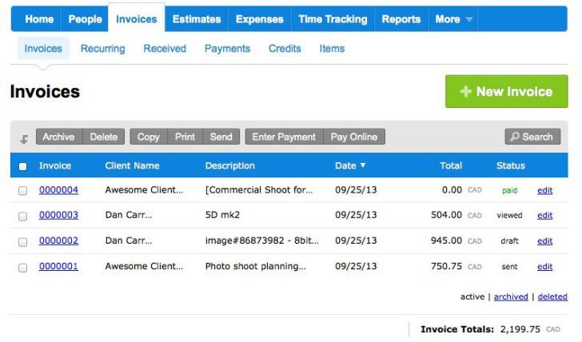

#### Figure 1: Cloud-based SaaS “Freshbooks*”*

(Source: Sanaei *et al.* 2014)

## Changes required in adoption of cloud-based SaaS

*“Five Point Four”* needs to change their existing hardware to make it compatible with cloud environment. A mainframe computer system is recommended to support virtualization process.

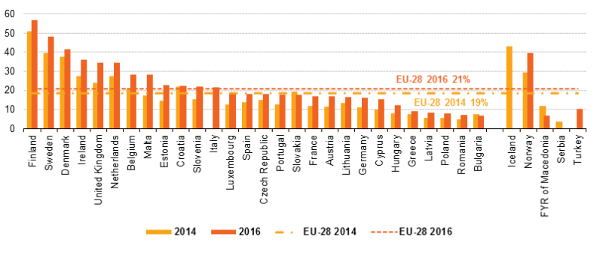

#### Figure 2: Cloud adoption in worlwide business

(Source: ec.europa.eu, 2016)

# c. Comparison of Solutions

## Summarization of software

|  |  |  |  |  |
| --- | --- | --- | --- | --- |
| Software | Website | Price | Advantages | Disadvantages |
| *“Xero”* | https://ww.xero.com/au/pricing/ | * $25 /mo * To send 5 invoices * To enter 5 bills * 20 bank transactions are allowed * Payroll for one person * $50/mo for unlimited invoice and bills * Payroll for 2 people * $65 for payroll up to 5 people | As a cloud-based software it posses   * Unlimited memory * Virtualization * Centralization | As a cloud-based software, its disadvantages are:   * Security * Cost * Implementation |
| *“Freshbooks”* | https://www.freshbooks.com/pricing | $7.50/mo for lite version (5 clients)  $12.50/mo for 50 clients  $25.00/mo for 500 clients | * Ease of accessibility * Speed of computing * Centralized access * Unlimited memory | * Third party authentication is not secure * Expensive |
| *“QuickBooks”* | https://quickbooks.intuit.com/pricing/ | $10/mo basic features (single user)  $17/mo for basic features along with bill managers and Multiple users (maximum 3)  $30/mo for more than five clients | * Ability to tackle various kinds of data * Multiple users are supported * Core server can be maintained * Desktop version offers more security | * Cost of cloud-version is high * Security risk is high |
| *“AccountEdge”* | https://AccountEdge.com/pricing/ | $499 one time free license | As an ERP based software, this supports   * Banking, Sales and General Ledger * Payroll services * CRM services * HR management * Project Management * Warehouse management * Production planning * Desktop version provides security and ease of access | * Third party authentication problem * Interface is less secure * Multi Factor authentication is not supported in cloud version * Desktop version is not equipped with all the features |

**Table 3: Comparison of four softwares**

(Source: Rittinghouse & Ransome, 2016)

# d. Conclusion

**Recommendation of software**

The aim of this report is to recommend accounting software for *“Five Point Four”* Company. The above discussion has provided a complete description including advantages and disadvantages of cloud-based accounting software and desktop-based accounting software. The following recommendation is based on the above discussion.

*“Xero”* and Freshbooks are purely cloud-based software. No version of these two types of software supports in the conventional desktop systems. It would be expensive for a new SME like *“Five Point Four”* to implement. The hardware requirement to support these two requires modification of entire IT infrastructure of *“Five Point Four”*. Thus, along with cost, it would require quite an amount of time to halt the business processes. Thus, these two despite their advantages are not beneficial.

*“QuickBooks”* and *“AccountEdge”* are two software tools that come in both desktop version and cloud version. Thus, it would be beneficial for *“Five Point Four”* to use one of these two. As desktop version is supported, business processes can be continued simultaneously with up gradation process. The software are designed in such a way that software version can be upgraded to cloud version, although initial requirement of hardware is required as for any cloud version. As implementation in a new manner is not required, it saves time.

Now a comparison of “*QuickBooks”* and *“AccountEdge”* shows that, *“QuickBooks”* can be only used for accounting purpose. Only several types of data related to finance and accounting can be tackled with this software. On the other hand, *“AccountEdge”*, despite its high cost compared to QuickBooks, provides numerous advantages. *“AccountEdge”* supports various functions, such as accounting, HR management, Production planning, CRM services and Payroll services. Thus, as a whole, *“AccountEdge”* is ERP software, which supports several functionalities. The function of an ERP is not bound to any function, but it is multitasking software. Along with accounting, one of the most important parts of business policy of any company is customer feedback and data related to customers’ choice. ERP software along with data storage and collection can also perform data analysis. Data analysis helps to detect future demands of customers, which can help respective company to organize their business polices accordingly. ERP software can plot graph and chart based on data analysis. Thus, a visual presentation is also possible using this software. It is to be noted that cloud version of *“AccountEdge”* is required to get access to this features. In coming future, these features will be required to tackle heterogeneous data. Therefore, *“AccountEdge”* is recommended for *“Five Point Four”*.