# Limestone Manufacturing Process Assessment Answer

Background theory of equilibrium: Research and write 250-300 words about equilibrium. You can use the following questions as a guide

1. Collision theory
2. What is an equilibrium system?
3. Le Chatelier’s principle.
4. Factors that affect an equilibrium.

Your chosen industrial process: Research and write 600-700 words to discuss the following factors in designing your chosen industrial process.

1. Chemistry of the reaction
2. Reaction conditions
3. Availability of reagents
4. Industrial uses
5. Environmental, social and economic implications

## Answer

****Limestone manufacturing process****

The reaction for the manufacturing process of limestone is a based on the raw materials that will be based for the primary composition for the same. In the manufacturing process, the limestone is ground and crushed into fine power.  Later, the crushed limestone is combusted so as to break down the carbonate; thermal decomposition. This is considered as a highly reactive and an exothermic reaction. The limestone at this stage is referred to as the quicklime. That can be processed as follows below.

IMG_256

During the exothermic process, there is a smaller portion of the water that is used up for the when converted into steam. This will form the calcium hydroxide as follows;

IMG_257

The crushing process would require some care and also there is the need for the sorting and grading to the various fractions. The ground limestone can be referred to us the ground quicklime. This will form the basis for the mixture with the reagents that will breakdown the limestone further during the process.

****Availability of reagents****

The resulting product is the formation of calcium oxide (un-slaked lime). This will can be dissolved to form lime water. The formation of the hydroxide that is considered as a base with further lower the pH for the resulting solution. Also during the process, there are formation of other by products. These can be seen in the figure below. For the industrial application, there is the process that will allow for the gasification for coal so as to generate Hydrogen gas that will aid in the efficient extraction of the Calcium oxide form the limestone.

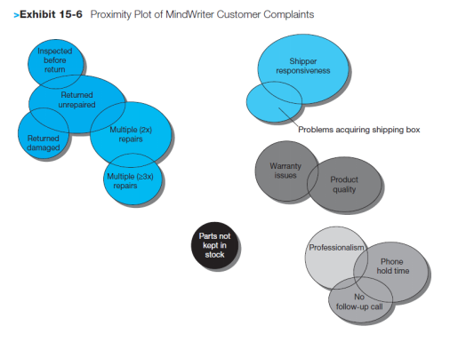

Figure 1: Limestone manufacturing process

(Dahlquist, 2013)

****Industrial uses****

The limestone is used in the manufacturing industry extensively in the construction in the concrete manufacture as a component. Also for the industrial use, Limestone is used in the paint manufacture. This has seen the use of the various paints grown from the waster based paints to the limestone additives that are quite durable (Suleiman & Naaz , 2019). The other uses of limestone include the agricultural sector where the limestone can be used to offset the soil ph. This will see to the increase of the pH from the acidic nature to balance out. This will factor the growth of crops and also improve on the soil. The limestone has also had extensive use in the water water treatment for the recycling plants. This is mainly used for the Ph. offset and also improve on the water impurity precipitation process (Suleiman & Naaz , 2019). Finally, the limestone is one of the key raw materials that is sued for the manufacture of glass.

****Environmental, social and economic implications****

The limestone is a mineral that has to mined out that would mean excavation of the earth. This will lead to the formation of quarries that pose a human health from the process. The limestone itself tends to have a lot of precipitate and would accumulate in the immediate air that would lead to pollution of the near environs. The pollution can be fatal to the miners and the nearby residents that inhabit the location around the quarry. Also, for the complete mining and conversion of the limestone to slake like o quicklime, there would be the value addition that would lead to the sales for the same. This would improve on the economic value for the stones and hence a source of income. For the social implication the mining would lead to the integration of communities that would work together for a common goal to improve their well-being through economic empowerment.